Project Design Phase-II
Data Flow Diagram & User Stories

Date | 02 July 2026
Team ID
Project Name | Food Ordering Behaviour and Consumer Trends
Maximum Marks | 4 Marks

Data Flow Diagrams:
A Data Flow Diagram (DFD) is a traditional visual representation of the information flows within a system. A neat and clear DFD can depict the right amount of the system requirement graphically. It shows how data enters and leaves the system, what changes the information, and where data is stored.

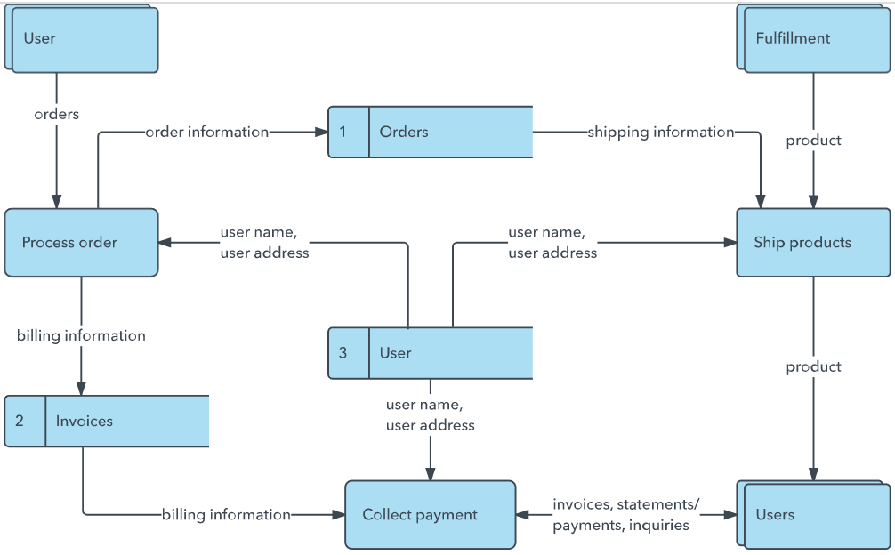

User Stories
Use the below template to list all the user stories for the product.
User Type | Functional Requirement (Epic) | User Story Number | User Story / Task | Acceptance criteria | Priority | Release
Customer | Restaurant Search | US-01 | As a customer, I want to search restaurants by cuisine, rating, and price so that I can quickly find my preferred restaurant. | User can successfully filter restaurants based on selected criteria. | High | Release 1.0
Customer | Order Tracking | US-02 | As a customer, I want to track my food order in real time so that I know when it will be delivered. | Customer can view the current delivery  status and estimated delivery time. | High | Release 1.0
Restaurant Owner | Customer Analytics Dashboard | US-03 | As a restaurant owner, I want to view customer ordering trends so that I can make better business decisions. | Dashboard displays  order trends,  popular cuisines,  peak order times,  and customer  preferences. | Medium | Release 1.1

